The power and possibility of remembering
November 2019
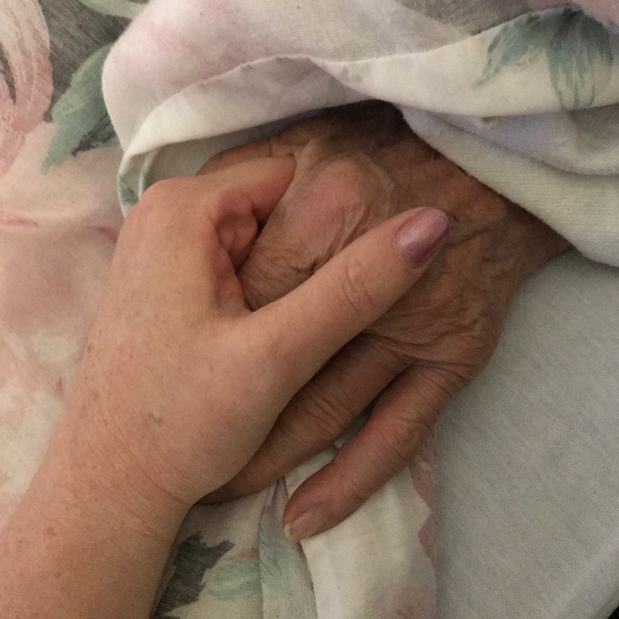
I got to spend two beautiful evenings with my Grandma in the week before she died last month. While I held her hand and listened to her stories, and then to her breathing when she couldn’t speak anymore, I was flooded with memories. Picking raspberries and eating more than we put in the bucket. Sitting on the swing in her garden. Watching parades and going camping. Crawling into bed on Saturday morning after Friday night sleepovers. Sometimes, remembering is effortless.
And sometimes it’s not.
Grandma also talked about the harder memories of the last couple years. She reminded me about the babies we lost, and she talked about the hardest parts of losing Grandpa. And then, she shared some of the fears that remained from Abbie’s death. In the last couple of years, I have learned that some remembering can dismember me.
Traumatic memories replay like nightmares in all hours of the day and attach themselves to ordinary life in really awful ways. And recovering from some post traumatic stress symptoms over the last year has been a process of dislodging memories from where they got stuck. The healing has been about allowing a richer and larger pool of memories to put me back together. To let the hard pieces be just their small part of the story of my life.
The year we turned 12, Grandma drove to a neighbouring town to buy us some of our first cassette tapes of our very own. Abbie had been hoping for Ace of Base, and I desperately wanted Reba McEntire. When we opened the gifts, Abbie’s was exactly perfect. Mine was Rita MacNeil. Grandma was so proud of her gifts, that I could not bring myself to tell her. I used other birthday money to buy the tape I wanted because I couldn’t return it.
Years later, I found myself speaking in Cape Breton, the week the Rita MacNeil died. I was billeted by a woman who cared for me like my Grandma. We drove by church while her funeral was happening and went to a concert where the Men of the Deep sang a tribute to their leading lady. Everywhere I went that week, I heard the stories of this incredible Canadian woman and her strength. And, twenty-some years later, I was grateful for my grandma’s gift in a way my twelve-year-old self could never have anticipated.
While Grandma recounted the events leading up to her hospitalization with her signature gastric detail, I felt re-membered by all the memories of her. Potting soil in the veranda, Noxema face cream in the bathroom, the hand-made afghan on the couch. Listening to “Boots and Salutes” on the radio in her kitchen. The jar of tiny spoons she let us eat with. Homemade soup and buns and pie. Abbie and I lying in the spare bed in Grandma’s basement, trying desperately not to roll into the low spot in the middle, and then giggling uncontrollably when we crashed into each other on the verge of falling asleep. And then Grandma’s voice telling us it was time to go to sleep.
Remembering isn’t only sentimentality and tradition, though both of those would be enough. Remembering is a sacred act of time travel into the places and people and feeling and smells and sounds that make us connected and beautiful.
One of my earliest memories is when I realized that I could choose to remember. I was about four, sitting in the living room staring at my grandma laughing loudly, surrounded by our family. I remember the smell of her soap wafting over the light in her eyes and the joy in her. Abbie was playing on the floor beside Grandma, completely oblivious to the conversation above her. They were both wearing purple and blue. I willed my little self to remember to see if I could.
In real time, Grandma filled me with experiences of the most ordinary miracles. And the memories become the most extraordinary kind of healing for a grieving heart. Hug our people for me, Grandma. And when I forget myself from time to time, remember me too, okay?

